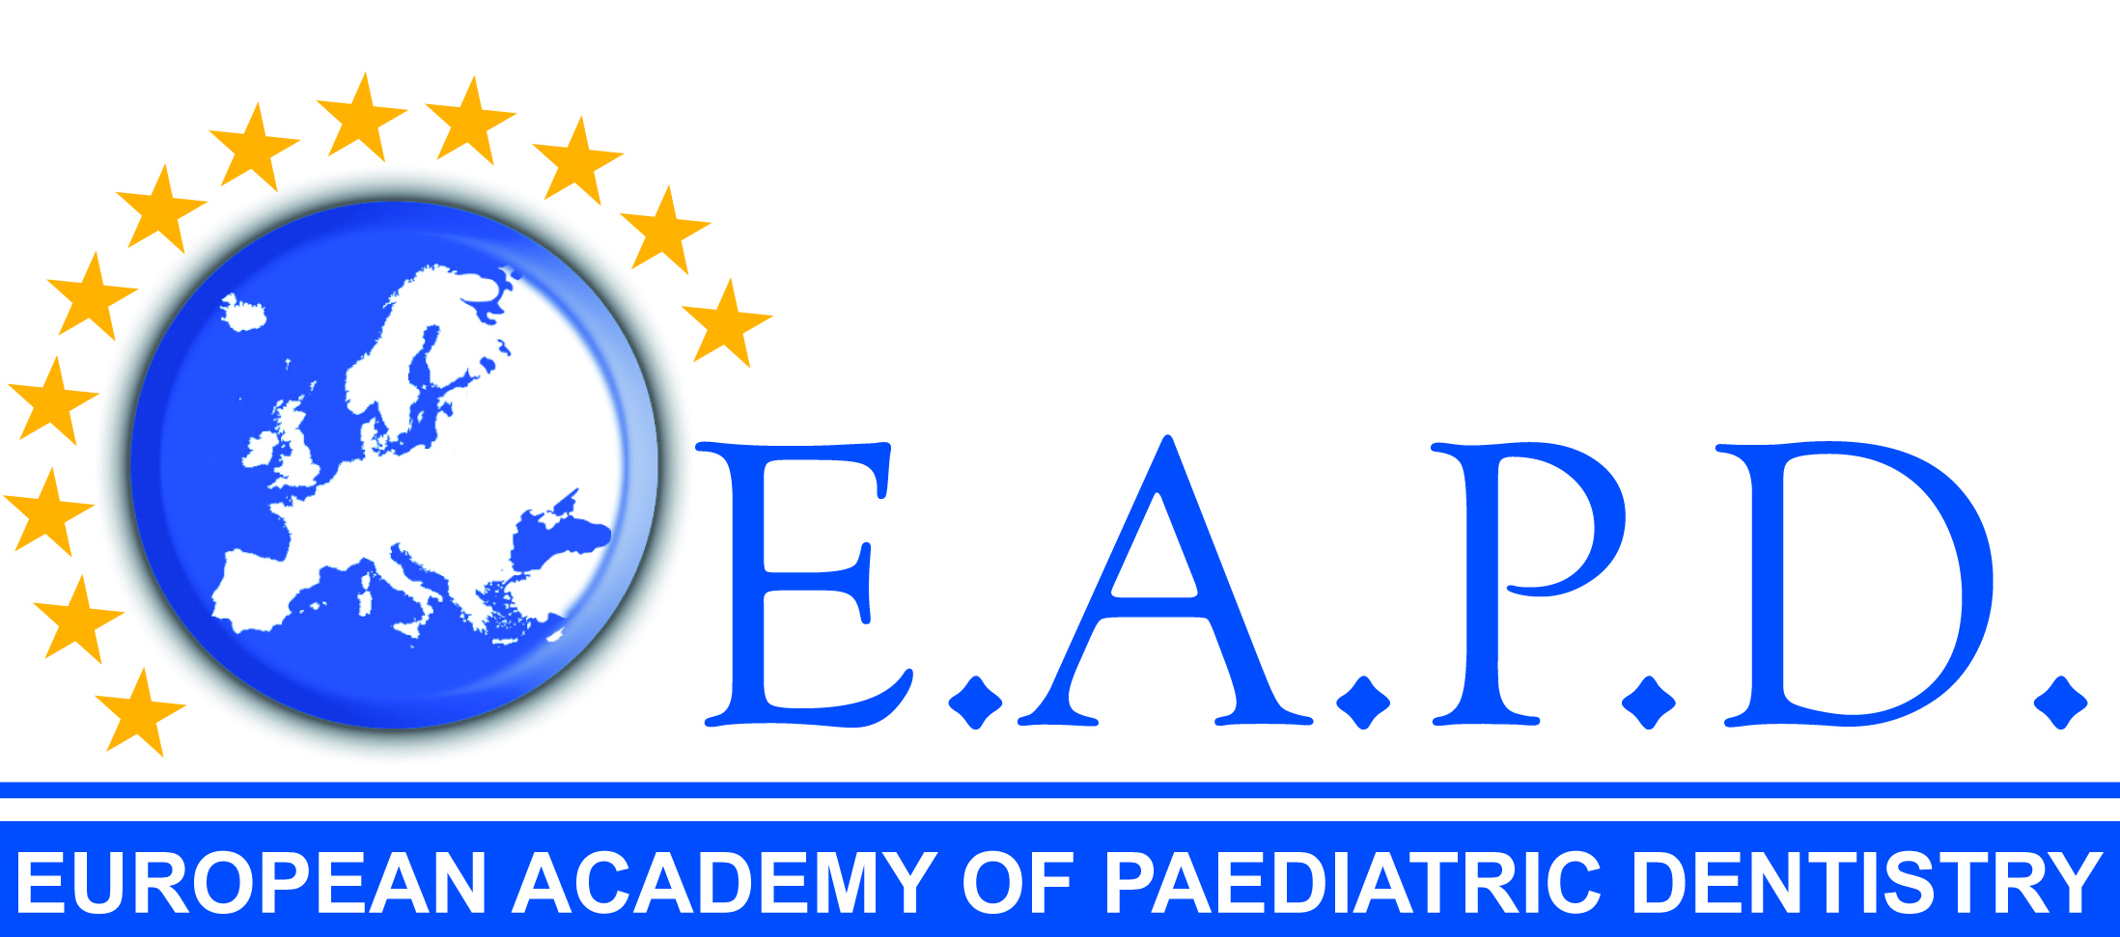

Martin Curzon Research Travel Award
Application Form

Active members of EAPD who have completed their postgraduate education in Paediatric Dentistry within the last 5 years are invited to apply for the Martin Curzon Research Travel Award of up to €5,000. This award is to support the attendance of the successful applicant at a specialist centre/unit in a different country from where the applicant graduated, for a fixed period of time for research, education or development of clinical skills in Paediatric Dentistry. The award is limited to candidates whose membership (including student membership) of EAPD has been in good standing for at least 3 consecutive years.

Name:
Job Title:
Email:
Work Address:
Work Tel:
Mobile tel:

Summary of intended research, education or clinical skills*:

Financial costs*

Other funding*:

* A separate sheet can be attached if necessary

Signature:
Date:
Signature of the Head of the Department
Date:

Please return this completed form with a short CV as an e-mail attachment to the President of
EAPD (president@eapd.eu).

The decision by the Board of EAPD in relation to assessment of an application and awarding or not awarding of a Martin Curzon Research Travel Award and the value of the award will be final.

